HOTEL RESERVATION

ANALYSIS REPORT

Prepared By: Pratima Kandel
Project Title: Hotel Reservation Data Analysis Using Power BI
Course: CSDA 5310
Instructor: Dipak Biscuitwala
Webster University
CSDA 5310 Data Visualization

DATE: May 7, 2025
CONTENT Page
- Executive Summary Page 1
- Context Page 1
- Introduction Page 2
- Objective Page 3
- Exploratory and Explanatory Analysis Page 3-4
- Dashboard Insights Page 5
- Business Impact & Recommendations Page 6
- Challenges & Limitations Page 7
- Conclusion Page 8
- References Page 9
- Dashboard Page 10

Executive Summary
This project is about looking at hotel bookings to learn more about how guests behave when they make reservations. I used a dataset from the website Kaggle and created a dashboard using Power BI. The goal was to find out what influences people to cancel or keep their bookings, to find out revenue potentials how pricing and room choices affect decisions, this helps hotel managers make smarter choices about how they run the hotel.
Context
Online booking platforms have changed how people reserve hotels. However, this flexibility has also increased cancellations and no-shows. Many guests change their plans and cancel without penalties. While this is convenient for them, hotels face challenges such as empty rooms, reduced profits, and last-minute adjustments. The goal of this analysis is to understand booking behaviors and recommend ways to solve this issue.

Introduction
Today, most people book hotels using websites or apps because it’s fast, easy, and often allows free cancellation. While this is very convenient for customers, it can cause big problems for hotel businesses. Many guests cancel their bookings at the last minute or simply don’t show up, which means hotels lose money and can't fill those rooms with other guests in time.
For this project, I worked on a dataset from Kaggle called Hotel Booking Reservation, which includes information about hotel reservations from a city hotel and a resort hotel. The dataset contains many useful details, such as:
- Booking status (whether it was canceled or not)
- Room types
- Lead time (how early the reservation was made)
- Meal plans
- Market segments (such as corporations, online travel agents, etc.)
- Average price per night
This data helped me explore booking patterns, customer behaviors, and the reasons behind cancellations. I used Power BI to visualize and analyze this information. With these tools, I was able to identify my objectives and come up with recommendations that hotels could use to reduce cancellations and improve their business.

Objectives
The main goals of this analysis are:
- To understand customer behavior and how it affects cancellations.
- To find out which room types, customer segments, or meal plans are more likely to be canceled.
- To suggest ideas that can help hotels reduce cancellations.

Exploratory and Explanatory Analysis
Data Collection:
I used the Hotel Booking Demand dataset from Kaggle, which includes real-world hotel booking data from a city hotel and a resort hotel. I chose this dataset because:
- It is reliable and used by many for learning and research.
- It contains useful details like room types, customer types, booking status, and price.
- It is perfect for practicing with Power BI and learning data visualization.

Metadata Overview
Some important columns were:
- Type of meal plan
- Room type
- Market segment (online, offline, corporate)
- Booking status (canceled or not)
Data Cleaning:
The dataset wasn’t perfect. There were messy column names and missing or odd-looking data. I spent time cleaning it up to make sure my charts would be correct and meaningful.
Tools Used
For this project, I used:
- Microsoft Power BI to create dashboards and charts.
- Excel to view and organize the data before uploading it to Power BI.

Dashboard Insights
- Booking Status: About 28.17% of bookings were canceled, while 71.83% were completed.
- Room Types: Room Type 1 was the most booked, both by people who canceled and those who didn’t.
- Guest Loyalty: Most guests (over 99%) were new, not repeat visitors.
- Revenue: Total revenue was 1.86 million dollars across 3,930 bookings.
- Average Room Price: The average price per room was $116.63.
- Market Segment: Almost all the revenue came from online bookings. Offline and corporate bookings were very few.
- Lead Time: Most bookings were made with short notice, but there were also some made far in advance.
- Meal Plan Preferences: Meal Plan 1 was the most selected, with a few using Meal Plan 2 or not selecting any.

Business Impact & Recommendations
- Lower Cancellation Rate: Since 28% of bookings are canceled, hotels could reduce this by offering free cancellation up to a certain date, then charging a small fee after that.
- Target New Guests: Because nearly all guests are new, it’s a chance to introduce a rewards program to turn them into repeat visitors.
- Online Booking Focus: Most revenue came from online bookings, so the hotel should continue investing in their website and digital marketing.
- Flexible Pricing: The average price is $116.63. Hotels could offer discounts during slower months or bundle deals (e.g., room + breakfast) to increase bookings.

Challenges & Limitations
- Data Cleanliness: The data was not clean at first. It had missing values and unclear labels that had to be fixed manually.
- No Guest Names or Contacts: We couldn’t track individual guest behavior or segment them into types because personal information was not provided.
- No Exact Booking Time: We had arrival dates but not the time when bookings were made, which made it hard to analyze last-minute versus early bookings in detail.
- Unbalanced Data: Some options like Meal Plan 2 or offline bookings had very few records, so comparisons may not be accurate.

Conclusion
By using Power BI, I turned a complex dataset into a clear and visual story. The dashboard helped highlight guest preferences, common cancellation patterns, and which sales channels bring in the most money. This kind of analysis is important for hotel managers who want to make smart choices and improve their business. I learned a lot about data cleaning, dashboard design, and how even simple charts can answer big business questions.

References
Kaggle. (n.d.). Hotel Booking Demand Dataset. Retrieved from:
https://www.kaggle.com/datasets
Microsoft Power BI Documentation. (n.d.). Retrieved from: https://learn.microsoft.com/en-us/power-bi

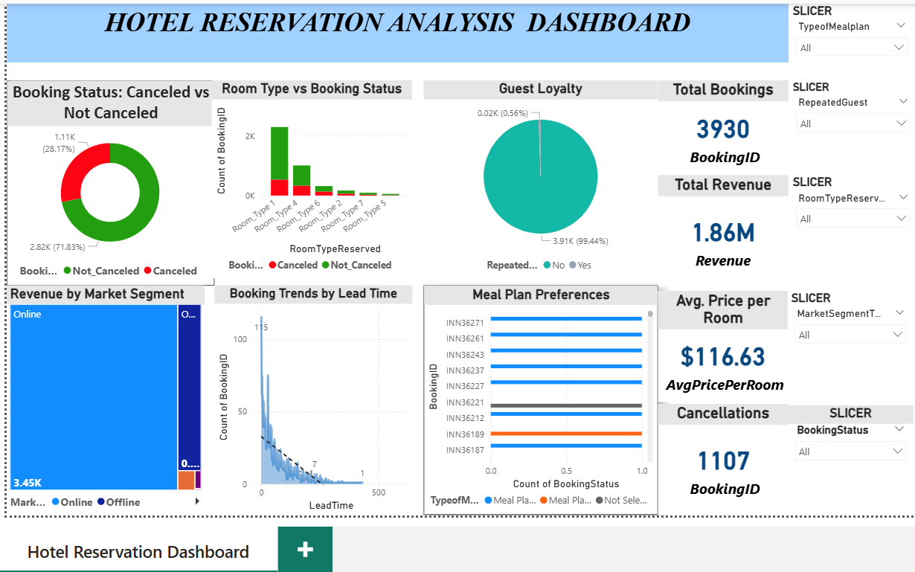
DASHBOARD

